# Python Web Basics Exam – Animal Care

*"Animal Care" is an application where vets can add sick animals, edit their data, see their details and add them to the "cured" list.*

## Skeleton

You are provided with all the **html pages**, all the **images** and the **CSS** for the project.

**Database – 5p**

You will need **1 model**:

* **Animal**
  + **name** - Character field with **max length** of **20 characters**
  + **image_url** - URL field
  + **description** - Text field with **max length** of **250 characters**
  + **priority** - Character field with only **3 possible choices** ("**low**", "**medium**", "**high**")
  + **is_cured** - Boolean field (**False** by default)

## Routes

* **'**[**/**](http://localhost:8000/)**'** - home page
* **'**[**/create**](http://localhost:8000/create)**'** – add animal page
* **'**[**/edit/:id**](http://localhost:8000/edit/:id)**'** - edit animal page
* **'**[**/delete/:id**](http://localhost:8000/delete/:id)**'** – confirm delete page
* **'**[**/details/:id**](http://localhost:8000/details/:id)**'** - animal details page
* **'/cure/:id'** – cure the animal and redirect to home

## Pages

### Home Page – 30p

If there are **no sick (and/or) no cured animals** yet:

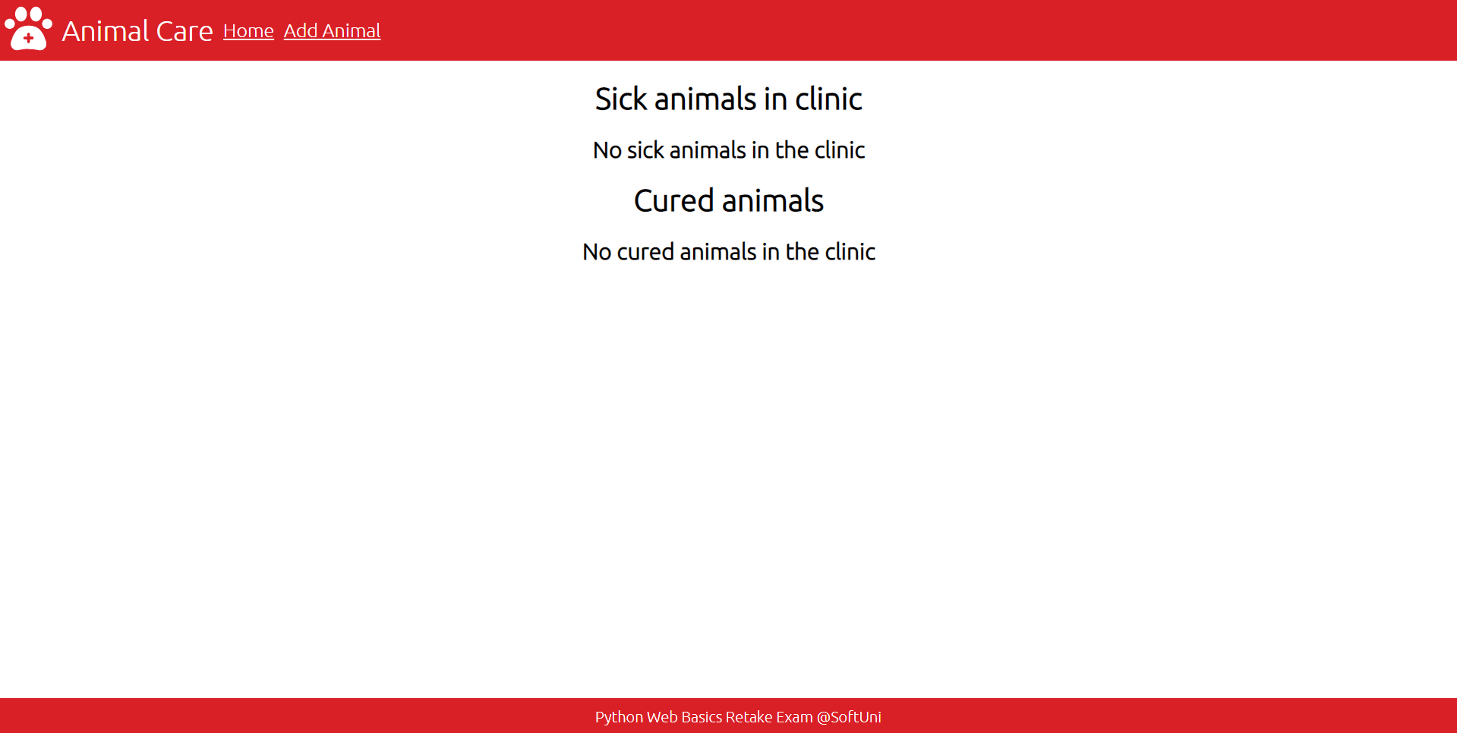

***Note:*** "**Sick animals in clinic**" and "**Cured animals**" should **always** be **visible**. "**No sick animals in the clinic**" should only be visible if there are **no sick** animals. "**No cured animals in the clinic**" should only be visible if there are **no cured** animals.

If there **are sick (and/or) cured animals**:

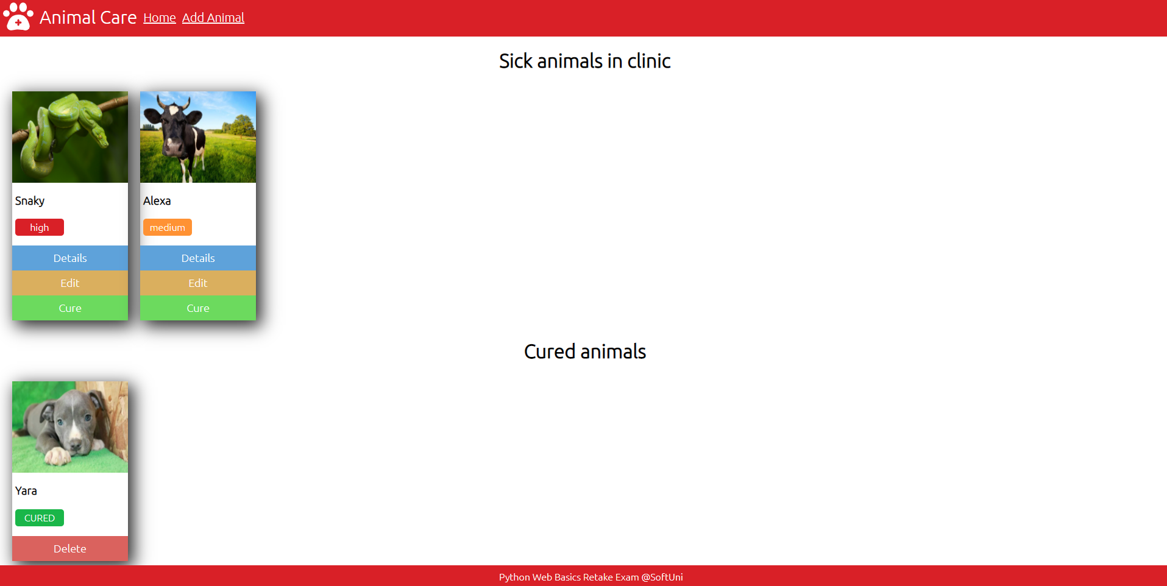

* The **sick animals** should be **sorted** by **priority** in **descending (high -> low)**
* **Cured animals** should display **"CURED"** instead of their priority
* **Sick animals** should have **"Details"**, **"Edit"** and **"Cure"** buttons
* **Cured animals** should have only **"Delete"** button

### Add Animal Page – 15p

The **default** value for priority should be **"Low"**. After the button is clicked, **create** the animal and redirect to home.

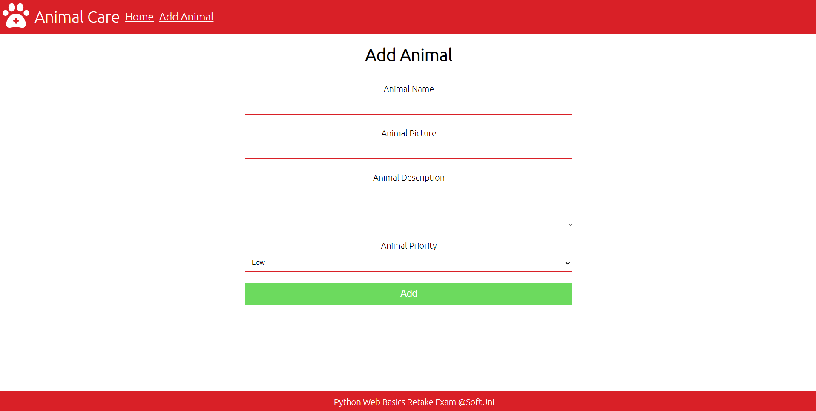

### Edit Animal Page – 15p

The form must be **filled** with the **data** of the **animal** we want **to edit.** When the button is clicked, **edit** the animal and redirect to home.

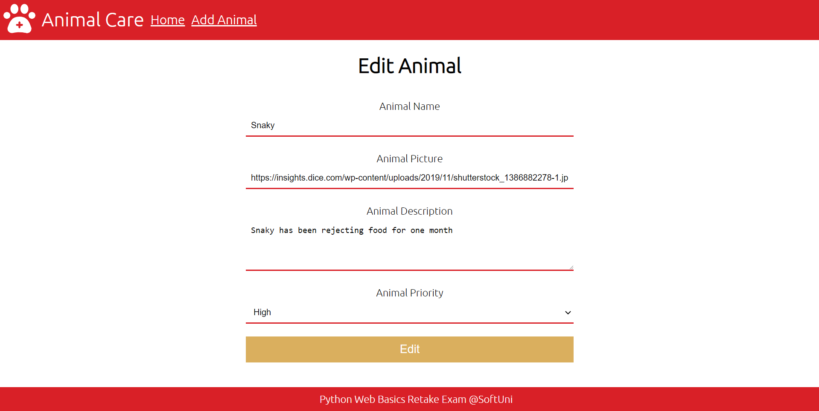

### Delete Animal Page – 10p

If the button **"Go Back"** is clicked, you have to **redirect to home**. Otherwise if the **"Yes"** button is clicked, **delete the animal** and then **redirect to home**.

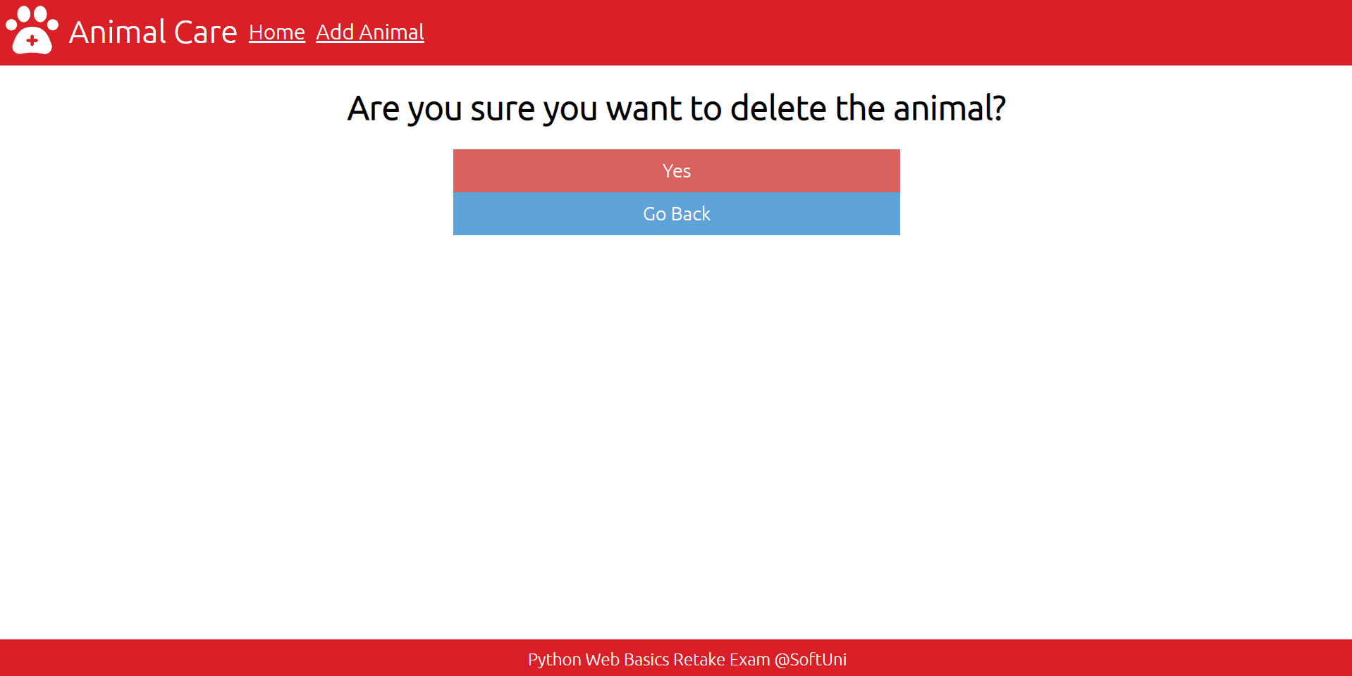

### Animal Details Page – 15p

Fill the **needed data** about the animal (name, priority, description and the image). Make sure that the **buttons** in the template **work** as well!

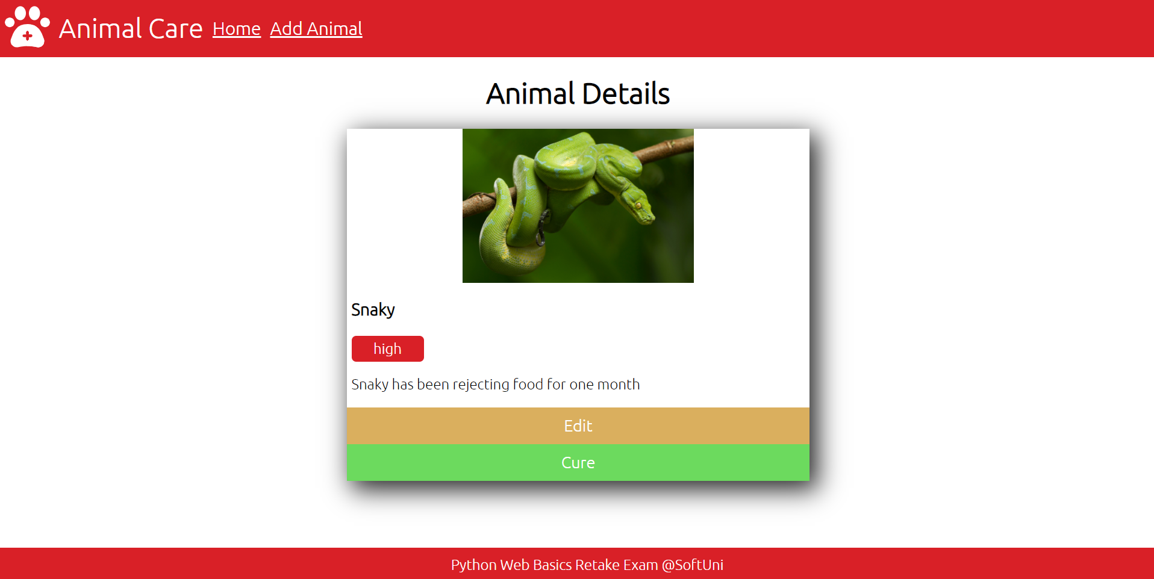

### Cure – 10p

When the **"Cure"** button is clicked, **cure** the animal and **redirect to home**. The animal should then **move** from the **"sick"** section to the **"cured"** section.